Growing in STEM Grant Planning Worksheet
Grant applications are due by 5:00 pm on Friday, December 4, 2026.

Use this form for internal planning. Contact grants@sccoalition.org with questions.

Provide the following information in the order presented. Limit your total responses to the word counts indicated below. You will submit your budget sheet with your online application using the template provided.

Applicant Information
First Name
Last Name
Job Title
Email Address
Phone Number
Grade Levels Taught
Subjects Taught

Optional: Co-Applicant 1 Information
First Name
Last Name
Email Address

Optional: Co-Applicant 2 Information
First Name
Last Name
Email Address

Optional: Co-Applicant 3 Information
First Name
Last Name
Email Address

School or Organization Information
District Name |  | if a SC K-12 Public School
School Name
Street Address
City
Zip Code
Region Number |  |  | See the map below

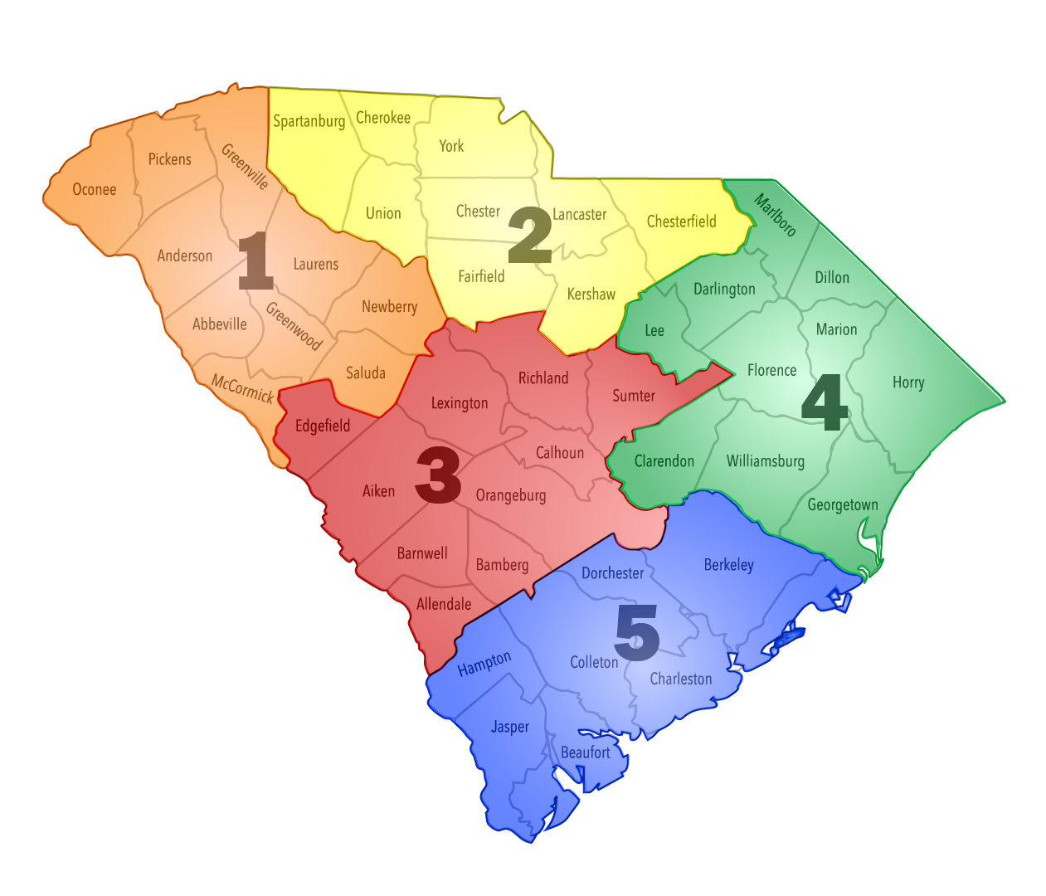

Principal or Site Leader Information
First Name
Last Name
Email Address
Phone Number

Project Information
Do NOT include any organizational identification in your answers.

STEAM Project/Unit Title:
This should be short, creative and on point.
Summary
Write a short, one paragraph, summary/description (to be used for publicity in the event your grant is funded). Be creative! Show how you will grow STEAM in SC through your words! (Include who, what, why, and how.)
Project Start Date
The project start date must be April 30 or after.
Project Completion Date
Grant projects should be completed within one year.
Total Number of Students Involved
This should be a whole number. If you are using a range (example: 30 – 100 students), choose the upper limit.
Total Funds Requested
Grant awards will be up to $2,500
Total Budget
This may be greater than or equal to funds requested.
Additional Funding Justification
If your project budget exceeds $2,500, please indicate which source(s) you have secured other funding.

Upload Budget Worksheet
A completed budget must be submitted with your online application.

Download and complete the Budget Worksheet. Provide specific information on the items to be purchased with grant funds. Include the following information: item description, quantity of items needed, the vendor or place from which you will purchase the items, cost per item, and total cost of total number of items. Only include revenues and expenditures relevant to this grant request.

Note: you can save and edit the template as needed to accommodate your project budget.

Narrative Description (word limit 500)
Clearly describe your innovative project/unit idea and its connection to STEAM-related (Science, Technology, Engineering, Arts/Humanities, and Mathematics) fields, as well as the Profile of the SC Graduate.
Purpose/Goals (word limit 500)
Provide the project/unit’s purpose and state specifically what deliverables learners will be asked to produce. Provide data-driven measurable objectives.
Connection to Mathematics & STEAM Curriculum (word limit 500)
Summarize how the project applies curriculum concepts across STEAM (Science, Technology, Engineering, Arts/Humanities, and Math) fields. Specifically identify how the project connects to mathematics and which math standards are being addressed.
Evaluation (word limit 500)
In what ways will you determine if the desired learner outcomes have been achieved? List specific and quantifiable indicators for your project/unit and your method(s) for determining success.
Plans for Sharing (word limit 500)
Describe ways in which you will share specific lessons learned with colleagues related to the implementation and delivery of your project/unit.
Timeline (word limit 500)
Provide details on the timeline for implementation.
For example: May 2024, we will purchase materials. August 2024, we will begin the project. September – November 2024, students will continue working on the project. February 2025, students will showcase their work.

You’re ready to submit online!
Once you have finished filling out your planning worksheet, go to the Growing in STEM Grants online application to enter your information into the online application.

